New England colonies

The first New England colonies were established by the Puritans in present-day
Massachusetts. Most of the colonists came with their whole family to pursue a better life
and to practice religion as they saw fit. As a result of strict religious beliefs, the Puritans
were not tolerant of religious beliefs that differed from their own. Rhode Island was
founded by religious dissenters from Massachusetts who were more tolerant of different
religious beliefs.

Religious Reasons
Who established New England___________________________? And Where__________________
And Why____________________________________________?
For religious dissenters from Massachusetts who were not tolerated by Puritans, they founded ____________________________ . It became tolerant of different religious beliefs.

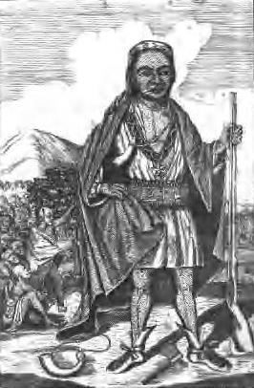
King Phillip’s War (1675–1676) was an early and bloody conflict between English
colonists and Native Americans. It was named after the leader of the Native Americans.
King Phillip’s Native American name was Metacom. Many colonists died in the war, but
it caused such a heavy loss of life among the Native American population that large
areas of southern New England became English settlements.

Relations with Native Americans
____________________________war was yet another conflict between the colonist(Massachusetts) and Native Americans.
King Phillip’s Native American name was__________________________
Explain why Southern New England became more populated by English settlers after King Phillip’s war__________________________________________________
Communities were often run using town meetings, unless the king had established control over the colony. In colonies that the king controlled, there was often an appointed royal governor and a partially elected legislature. Voting rights were limited to men who belonged to the church, and church membership was tightly controlled by each minister and congregation. As more and more children were born in America, many grew up to be adults who lacked a personal covenant (relationship) with God, the central feature of Puritanism. In response, Puritan ministers encouraged a “Half-way Covenant” to allow partial church membership for the children and grandchildren of the original Puritans.
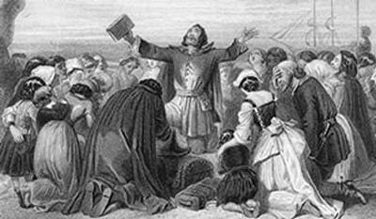

In 1686, the British king canceled the Massachusetts charter that made it an
Independent colony. To get more control over trade with the colonies, he combined
British colonies throughout New England into a single territory governed from England.
The colonists in this territory greatly disliked this centralized authority. In 1691,
Massachusetts Bay became a royal colony.

The government of colonial New England
How were communities (we mean government) run in New England without the king’s control________________________________.
How were communities run in New England with the Kings control?________________________________________________
Who was allowed to vote in New England town meetings?_____________________________
Religious tensions in New England
Religious commitment began to dwindle in New England, and therefore, the Puritan ministers encouraged __________________________ to allow partial church membership.
Who was allowed to participate in the half-way covenant? ___________________________________
Britain causes change in New England
In 1686, the King cancelled the__________________________, to get more control over trade between America and the colonies.
The king also made New England England into a _________________ governed from England. This is the beginning of colonial tensions with England.
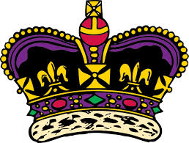
In 1691, _______________became a Royal Colony.

In the 1690s, the famous Salem witch trials took place. In a series of court hearings,
over 150 Massachusetts colonists accused of witchcraft were tried, 29 of which were
convicted and 19 hanged. At least six more people died in prison. Causes of the Salem
witch trials included extreme religious faith, stress from a growing population and its bad
relations with Native Americans, and the narrow opportunities for women and girls to
participate in Puritan society.
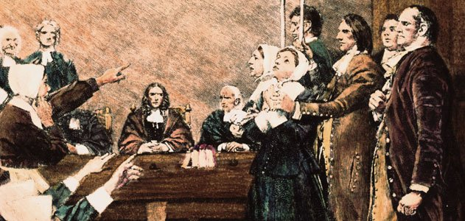

Salem Witch Trials
In 1690, The_____________Trials took place as a result of colonist accusing other colonists of witchcraft. The causes of the Salem Witch Trials were 1.____________________2. _____________________________________________3. ______________________________________________

