UNIT 6: PERSONAL FINANCE
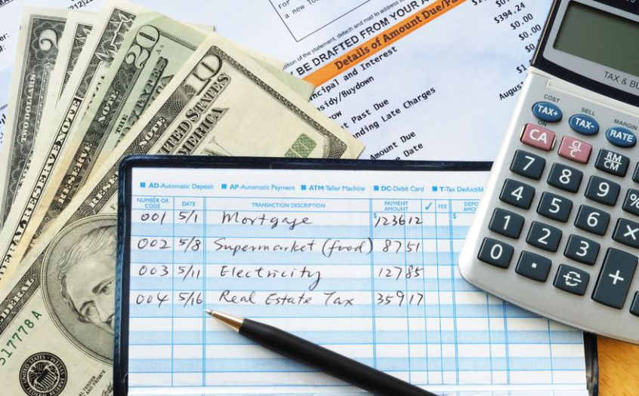

In Unit 6, you will study the fundamental concepts of personal finance economics. You will analyze how the household can gain and lose through various forms of personal savings/investment, insurance, credit, and skill development. You will evaluate how the potential gains and losses they predict could be affected by changing economic factors.
KEY IDEAS
• Importance of budgeting, saving, and personal investment (SSEPF1b)
• Compound interest (SSEPF4c)
• Risk vs. return of different types of personal investment options (SSEPF2c, d)
• Cost/benefit of credit (SSEPF4)
• Importance of education to future earnings (SSEPF6)
• Financial institutions and how interest is determined (SSEPF4a, b)
• Role of insurance (SSEPF5) • Tax system and who is affected (SSEPF3)
KEY TERMS
Savings are monetary deposits secured for a later, undetermined use. Money in savings might eventually be spent on groceries, a vacation, or some other form of consumption.
1. Why do you think it is important to have savings?

An investment is money used with the expectation of some future return or benefit.
2. What is the purpose of investing money?

Interest is money paid regularly at a particular rate. One way banks make profits is by taking the money deposited by bank customers and loaning out a portion to people who want to borrow. By charging interest on the loans, banks make money. The more money on deposit, the more loans they can make, which is why some banks offer very generous checking account services. The interest on the loans is always more than the interest paid out to depositors.
3. How do banks make profits?
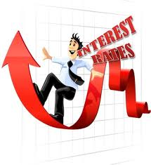

Commercial banks and other financial institutions offering loans are businesses. They must make a profit if they expect to continue operating. Banks make money by charging interest on loans. Banks are able to give loans because of the money that consumers have deposited with them. Banks encourage deposits by paying interest on money a depositor has in a savings account. The interest charged on loans is always higher than the interest earned on deposits. Banks make revenue by charging borrowers a higher rate of interest than they are paying to depositors. (SSEPF2b)
4. Why do banks charge higher interest rates on loans than deposits?

Types of Financial Institutions (SSEPF2a)
• Bank: For most consumers, banks provide a safe means to store earnings. Typically, banks also offer direct deposit (where a person’s paycheck goes directly into his or her account), check-writing services, debit and credit cards, loans of all sorts (personal, home equity, business), and a host of other services . In their basic form, banks take the money deposited in them and loan out a portion of these savings to people who apply for them. By charging interest on the loans, banks make money.
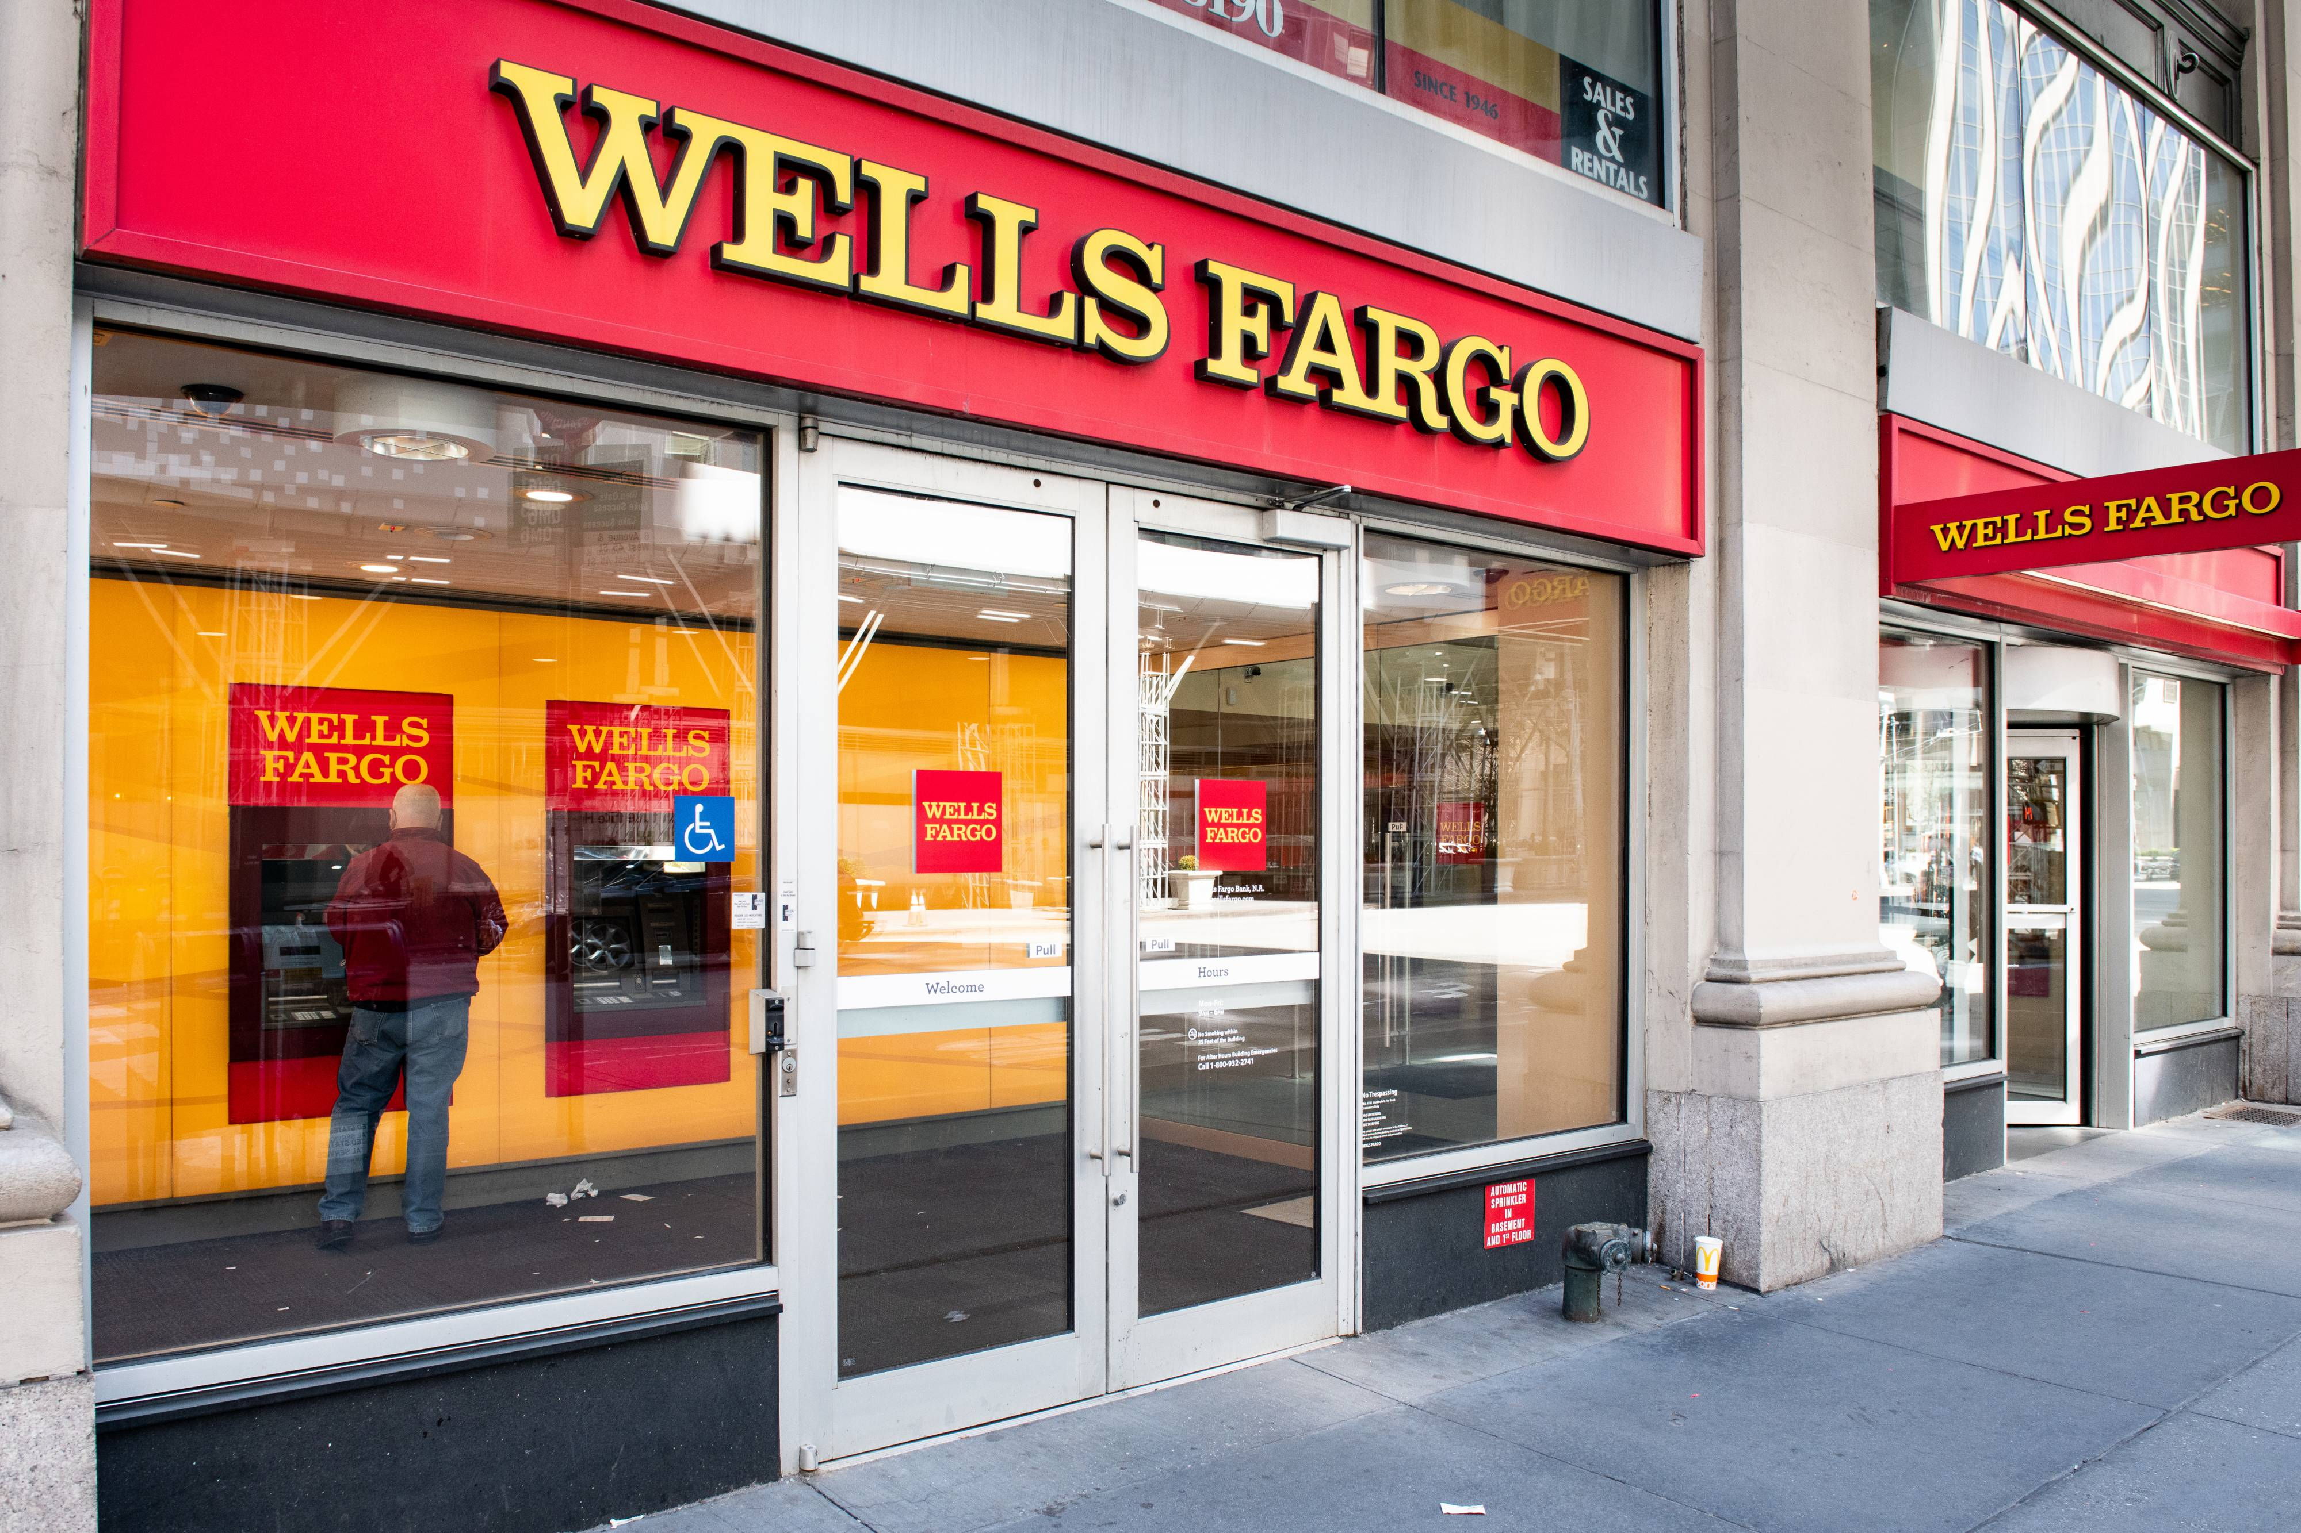
5. What services are typically offered at a bank?

• Credit union: A credit union provides services similar to those of a bank; the main difference is that a credit union only provides these services to its members, and these members own and control the institution.
6. What makes a credit union different from a bank?

• Payday lenders: A payday loan company will give out small loans in return for a portion of an upcoming paycheck.
7. What is a payday loan?

• Title pawn lenders: A title pawn lender will grant loans where borrowers can use their vehicle title as collateral or as security for repayment.
8. Title pawn lenders grant loans, but customers must use their ______________________ as collateral.

Savings and Investment Options
Some people like to take their earnings and attempt to increase their wealth through an investment. To accomplish this, they might buy government securities. These are quite safe, but they do not offer a very high return. Other types of investments are also known as securities. For example, bonds are regularly offered by governments and other entities (companies); by investing in them, the investor gets a promise that his or her investment will be repaid with interest. (SSEPF2d)
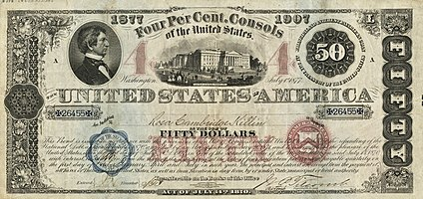
9. What is a bond?

Savings accounts are bank accounts that people put money into, which they are able to access at any time. Savings accounts are insured through the Federal Deposit Insurance Corporation (FDIC) up to $250,000, so there is no risk, but a savings account usually has a low interest rate. (SSEPF2d)
10. What is the downside of investing through a savings account?

A certificate of deposit is a savings certificate issued by a bank to a person depositing money for a specific length of time. The maturity date and the interest rate are fixed when the certificate is issued. (SSEPF2d)
11. What is a certificate of deposit? (In your own words)

A retirement account, such as a 401K, is a plan/investing tool used by people to earn and designate funds for retirement savings. These have little risk but money in the account usually cannot be used without penalty until the owner reaches a designated age. (SSEPF2d)
People who believe in the business prospects of a certain corporation can buy stocks in that company. In return for partial ownership of the company, the investor gives that corporation his or her money to spend. If the company does well, its stock price usually rises, which translates to an increase in the wealth of its stockholders. Some companies also pay out dividends to their stockholders, which are a portion of their profit. (SSEPF2d)
12. What type of risk do you seen with a retirement account?
13. What does it mean to invest in stocks?

Another form of investment is the mutual fund, which is usually a collection of various investments (stocks, bonds, and other forms of securities). The goal of a mutual fund is to have many people pool their earnings, thereby giving these individual investors much greater purchasing power as a unit. The accrued earnings are then used to buy a range of investment options, and any earnings made by the fund are distributed among the individuals. (SSEPF2d)
14. What is the goal of a mutual fund?

Whatever the investment, in finance, with risk comes reward. People willing to invest money in riskier ventures—such as young companies in emerging fields—run a high chance of losing their entire investment, but they also stand to make the most of their investment if the venture is successful. (SSEPF2c)
Inflation is the increase in the price level of goods and services in an economy over time. It generally harms an individual because wages tend to rise more slowly than prices. There are a variety of factors involved. Over time, workers will demand more money to keep up with having to pay higher prices, but in the short run inflation causes an increase in prices. If this increase is not matched by a similar increase in wages, workers will find that their paycheck can no longer purchase all the items it once purchased. (SSEMA1d)
15. Explain the relationship between inflation and wages.

Unanticipated inflation hurts lenders who lend at fixed rates. Borrowers who borrow at fixed rates will benefit from unanticipated inflation. Their interest rates remain stable as prices rise, and they pay back their loans with money that has less purchasing power than the money they borrowed. (SSEMA1d)
16. Who does unanticipated inflation hurt? Who does it help? Why?

Credit worthiness is a measure of a variety of factors, but it boils down to an attempt to determine whether you’ll be able to pay back a loan properly. (SSEPF4a)
Some factors that affect credit worthiness:
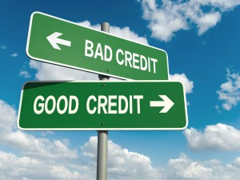
• character (credit score)
• capacity to pay
• collateral
17. What does it mean to be “credit worthy?”

The “Three C’s of Credit” are character, capacity, and collateral . Since most lenders do not know potential borrowers personally, they evaluate a potential borrower’s character using the information on the borrower’s credit report. It details the past seven years of a person’s borrowing and repayment history as reported to the three main consumer credit reporting companies by a person’s previous and current lenders . A potential borrower who has “paid as agreed” on all credit accounts has good credit character. The credit report also shows some aspects of capacity. While income is one factor in assessing capacity, the amount it takes to service current debt is also a concern . If the debt-to-income ratio is high, the borrower may not be able to handle additional debt payments . Finally, collateral is something of value a borrower can use to back the loan if the borrower can no longer pay the scheduled payments . For example, a home mortgage is available to people with lower incomes because the bank can seize the home if the mortgage is not paid .
18. What is the purpose of a credit report?

19. What does it mean to have good “character?”
20. What is used to measure your “capacity?”
21. What is collateral and give an example.

When you use a credit card and do not pay the balance off in full each month, you will be charged interest . If you place your savings in a savings account or other investment option, you will earn interest . The APR or annual percentage rate is the yearly rate charged for borrowing or the yearly rate earned through an investment . (SSEPF4b, c)
22. What is the annual percentage rate?

There are different types of interest rates . With a simple interest rate, the interest is determined annually with the original loan amount . With a compound interest rate, future interest is determined with the existing amount owed . Compound interest rates could lead to you owing more money in order to pay off the loan . (SSEPF4b, c)
23. What is the difference between simple and compound interest?

The type of interest to be paid is determined when the loan is opened . With a fixed rate, the interest rate is determined when the loan is originated, and it does not change . With a variable rate, the interest rate fluctuates over time because it is based on an index that changes periodically . (SSEPF4b, c)
24. What is the difference between a loan with a fixed interest rate and a loan with a variable interest rate?

Overall, taking out a loan or using some other form of credit can be very helpful in a variety of instances . In every case, a consumer must balance the benefit of having access to additional money with the cost associated with the interest and the financial difficulties that can result from defaulting on a loan .
Insurance
In general, all insurance policies allow a person or business to pay a relatively small amount of money (a premium) in the present to purchase asset protection against the possibility of a future financial loss caused by an unforeseen event . Assets that can be protected range from one’s home to one’s health . Most insurance policies include a deductible that stipulates the amount of money the insured must pay when a claim is filed with the insurance company . Purchasing insurance involves shared liability between the insurer and the insured .
25. In order to receive protection, insurance policies allow people to pay a ________________.

26. What is a deductible?

Automobile insurance is required by most states . At a minimum you need liability insurance to pay for the other vehicle(s) when you are at fault for an accident . You can purchase more insurance that will cover your own car in case of an accident . Health insurance is designed to pay for medical costs; disability insurance provides people with income in case they become injured or are unable to work at a job; life insurance provides a monetary payment when the insured person dies; and property insurance such as homeowners insurance pays for damages sustained to your real estate and for injuries to others that happen on your property . Another type of property insurance is renters insurance . It protects your personal property assets when you live in a rental property instead of a home you own . (SSEPF5a, b)
27. What is the minimum type of insurance you need if you drive a vehicle?
28. What does health insurance pay for?
29. Why would a person need disability insurance?
30. What is life insurance?
31. Why do homeowners need property insurance?

Factors That Affect Earnings
In general, the two factors that can boost the wages of a particular job are demand for that service and the training requirements needed for the job . High demand raises wages because it allows the limited supply of labor force in that area to ask for more money and get it . Additional training (educational or job specific) frequently raises wages and standards of living .
There are some skills or traits that will help you find success in the workplace, regardless of occupation . These include having a positive work ethic, punctuality or being on time, time management, teamwork, communication skills, and good character . (SSEPF6a, b)
32. Which 2 factors affect earnings?

Taxes
A progressive tax is a tax rate that increases as income increases, meaning the wealthy pay a higher percentage of their earnings than people less financially well-off . (SSEPF3a) A regressive tax is a tax rate that decreases as income increases . (SSEPF3a) A proportional tax, also known as a flat tax, does not change with respect to changes in income . (SSEPF3a) A property tax is the taxation of the value of real property (buildings and land) and personal property (stocks, bonds, etc .) . This tax is collected at the state and local level . (SSEPF3c) Like the different types of income taxes, a change to the sales tax affects different income groups in different ways . Since all consumers purchase essential goods like food, a high sales tax on food would affect poor people more than wealthy people because both groups will be paying the same tax rate for the same good . For this reason, economists usually classify sales tax as a regressive tax because it takes a greater percentage of income from a low-income person than from a high-income person . (SSEPF3b)
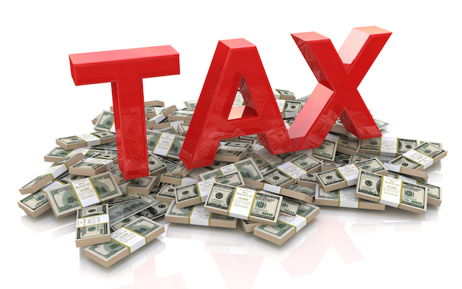
33. What is a progressive tax?
34. What is a regressive tax? Who does a high sales tax on food hurt?
35. What is a proportional tax and give an example.

Let’s do some practice questions!
Use the scenario below to answer question #1
Fifteen-year-old Calvin has inherited $3,000 from an aunt . He wants to invest in an option that has a very low risk but still increases the amount of money . He doesn’t plan to access the money until he attends college in two years .
1. Based on Calvin’s requirements, in which option would he MOST LIKELY invest?
A . precious metals
B . corporate stocks
C . a savings account
D . a certificate of deposit

2. A bank charges 6% interest on personal loans and pays 3% interest on individual savings accounts . Why is there a difference in the two amounts of interest?
A . The bank wants to make a profit .
B . The government regulates interest rates .
C . The bank wants to encourage people to save .
D . The government allows a system of credit buying .

3. When Jason bought a car and went to register it with the state Department of Motor Vehicles, he needed to show proof of insurance . What kind of insurance did Jason need to have?
A . disability insurance
B . automobile insurance
C . health insurance
D . life insurance

4. Which trait do MOST employers look for when hiring new employees?
A . punctuality
B . a fashionable wardrobe
C . an outgoing personality
D . financial independence

Use the scenarios to answer question #5.
Scenario 1: banks that loaned money at a fixed rate Scenario 2: people on a limited income Scenario 3: farmers with fixed-rate mortgages Scenario 4: businesses that profit from credit sales Scenario 5: convenience stores that sell staple goods Scenario 6: thrift stores that sell refurbished or used goods
5. Which TWO scenarios would be MOST negatively affected by unanticipated inflation?
A . Scenario 1
B . Scenario 2
C . Scenario 3
D . Scenario 4
E . Scenario 5
F . Scenario 6

Use the information below to answer questions # 6 and 7
A few years ago, Lori started a small software company . Sales have been steady and the company is considering expanding, but Lori has had trouble hiring and keeping skilled employees .
Part A
6. Which action would be the BEST way for potential employees to increase their chances of getting a job at Lori’s software company?
A . invest in more education or additional training
B . specialize in one aspect of production or service
C . buy stock in the company through payroll deductions
D . purchase the products or services the company develops

Part B
7. If Lori wants to develop a more efficient work force, which action would MOST LIKELY help her company accomplish this goal?
A . increase salaries for supervisors
B . reduce employee hours and tasks
C . install more safety and convenience features at the business site
D . provide employees with professional development opportunities

Copyright © 2017 by Georgia Department of Education. All rights reserved.

