The Issue of Scarcity
SSEF1 The student will explain why limited productive resources and unlimited wants result in scarcity, opportunity costs, and tradeoffs for individuals, businesses, and governments.
- Define scarcity as a basic condition that exists when unlimited wants exceed limited productive resources.

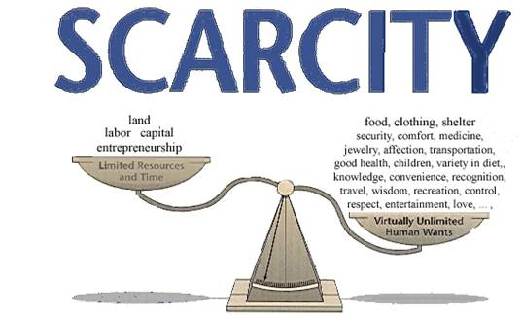

Directions: Read the following passage about scarcity to help you answer the questions at the end of the packet.

What is scarcity?
In economics, scarcity refers to limitations--limited goods or services, limited time, or limited abilities to achieve the desired ends. Life would be so much easier if everything were free! Why can't I get what I want when I want it? Why does everything cost so much and take so much effort? Can't the government, or at least the college or local town, or if not that, my parents just give it to me--or at least make a law so that if I want to buy pizza, there is a pizza shop nearby that has to sell me pizza at a dollar a slice?
That you can't have everything you want the moment you want it is a fact of life. Figuring out how individuals, families, communities, and countries might best handle this to their benefit is fundamental to what economics is about.
You are probably used to thinking of natural resources such as titanium, oil, coal, gold, and diamonds as scarce. In fact, they are sometimes called "scarce resources" just to re-emphasize their limited availability. Everyone agrees natural resources are scarce because they take a lot of effort, money, time, or other resources to get, or because there seems to be a finite amount available.
But what constitutes a lot of effort, money, time, or other resources? Does it matter if something is finite if we can easily substitute something else? It all depends on your circumstances. Most people don't think of water as scarce, but if you live in a desert, water is scarce. If you are a teenager or in college, iPhones or the hottest sneakers or the recognition of your peers or a person of interest are as scarce--as difficult to acquire--as gold. If you are running out of space on your hard drive but you can substitute cloud computing, is storage space scarce?
In fact, economists view everything people want, strive for, or can't achieve effortlessly as scarce. For example,
- Every time you turn on the tap and get fresh water, that fresh water is part of what economists deem as scarce. Instead of paying your water bill, you could instead hike down to the local river and fill your water bottle in the local stream or creek, as did your forbears only 100 years ago. That would involve your time, and even in the most pure of natural circumstances your worry about whether deer might have polluted the stream or creek with bacteria. Not to mention if you want to shower in clean water or water the summer vegetables you want to grow with clean water.
- The air we breathe and the sun that shines on us is free. But if the air we breathe or the sunlight we bask in are not as perfect or fresh or unpolluted as we envision, are you personally willing to pay more to make it so? If we make sweeping governmental, regulatory changes, are we sure that those changes are not major changes that might affect our friends or others on the earth badly? Or that won't come back to bite us, even making pollution worse?
- Time is scarce. Every minute you spend reading this is a minute you could alternatively spend reading a novel, catching a baseball game, talking to your friends or family, or working at a soup kitchen. Every time you have to give up something to enjoy what you want, the thing you want is scarce.

Video:
- Scarcity and Choice
https://www.youtube.com/watch?v=zcN0d8foBXI

Questions
- Based on the video and the reading passage, create your own definition of scarcity. (How you would define it in your own words)

- Scarcity is a condition when __________________ wants exceed limited _________________.

- What resources are available to people?

- Give an example where scarcity caused you to make a choice in your own life.

