additional project materials available: tinyurl.com/modernpresidents

In an effort to help you prepare for the EOC, you will be required to evaluate key successes and failures of the modern US presidents between 1945 and 2016. Currently, we are studying how sectional crises and the struggle for states’ rights within the system of federalism moved the nation to a civil war. Since the Civil War, there have been times of increased unity and increased division based upon political struggles. You will read and annotate the following guided readings to examine challenges faced by the modern presidents between the mid-20th and early 21st century. Jumping forward, events of the modern era parallel struggles that have continued to unfold since the early years of the republic. Remember: the Kentucky and Virginia Resolutions, the Nullification Crisis, and the secession of the southern states after the election of Abraham Lincoln have demonstrated that states sometimes struggle. Read the excerpt below and answer the questions to practice annotated and responding to the guided readings that follow.

Civil Rights and Federalism
During the Civil Rights movement, the process of integration, or de-segregation, was boosted by the Brown v. Board of Education decision. The Supreme Court had ruled in the 1896 Plessy v. Ferguson decision that "separate but equal" was the law of the land concerning segregation. In practice this meant that many states had created two systems of public accommodations - one White only, one Black only. In 1951, a Topeka, Kansas parent challenged segregation by suing his local school board. His daughter had to attend the Black elementary school that required her to walk a mile, even though the closest elementary school (White only) was only seven blocks away. The NAACP took on the case but lost on the Plessy precedent. The case was appealed to the Supreme Court. In 1954, the Supreme Court unanimously ruled, "...in the field of public education, the doctrine of 'separate but equal' has no place. Separate educational facilities are inherently unequal."

The Supreme Court ordered that public education be de-segregated, but no timeline was issued and school systems were slow to comply. In response to the Brown decision, Southern states organized the "Massive Resistance" movement, which shut down state education systems rather than integrate the schools. A notable example of this type of action occurred in Little Rock, Arkansas in 1957 when Governor Orval Faubus attempted to use the National Guard to block integration of Central High School by the Little Rock 9. President Eisenhower responded by federalizing the Guard and moving units of the 101st Airborne into Little Rock to enforce the law. Faubus countered by closing Little Rock's schools for a year.

1. Which supreme court precedent (and case) was overruled by Brown v. Board of Education?

2. How did the actions taken by Orval Faubus reflect states’ rights ideology?

3. What change began to occur in America as a result of enforcement of Brown v. the Board of Education?

President Harry Truman
Entering an Atomic Age
Harry Truman assumed the presidency in 1945 after the death of Franklin D. Roosevelt. Once he was sworn, in he was informed about a top secret project being developed by the military and some of the world’s top scientists: the atomic bomb. President Truman was conflicted on whether to use the bomb or not. He ultimately decided to use the atomic bombs based on the assumption that an invasion of Japan similar to that of D-day would result in an estimated loss of a million American lives.

Rebuilding Europe and the Beginning of the Cold War
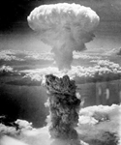
After WWII, Europe and many parts of Asia lay in ruins. The heavy bombing of the war had destroyed the infrastructure and crippled the ability of many nations to rebuild themselves. The United States and the Soviet Union began competing in rebuilding these war-torn nations. This competition led to a state of tension between the United States and the Soviet Union known as the Cold War. The United States foreign policy of preventing Communism from spreading to other nations was known as containment. The Truman Doctrine was issued in 1947 and stated that the United States would provide financial, political, and military support to democratic nations facing the threat of falling to communism. Aid was given to Greece and Turkey who were struggling to maintain their democracies. NATO was also formed to protect Western Europe from the threat of the Soviet Union. George C. Marshall, Truman’s Secretary of State, proposed a recovery plan for Western Europe that became known as the Marshall Plan. The Marshall Plan focused on containing the spread of communism by providing financial aid to Western Europe. Over 13 billion dollars were given to Western Europe to help establish free market democracies. Containment worked well in Western Europe but was not successful in Eastern Europe and many parts of Asia.

1. Which new technology/weapon is shown in image to the right?

2. Why did President Truman decide to use the atomic bombs on Japan?

3. What was the name of the foreign policy the United States followed concerning communism?

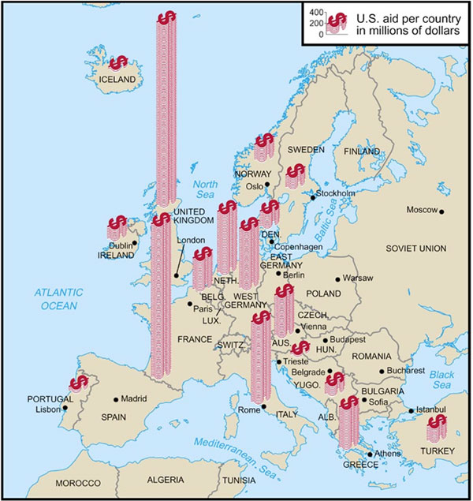
4. What types of aid would the United States provide Western European nations under the Truman Doctrine?

5. Use the image to the right to help you answer the parts to the question.

- The Marshall Plan would provide aid to who?

- What type of aid would the Marshall Plan provide?

McCarthyism
The fear of the spread of communism and the increasing tensions between the United States and the Soviet Union led to an increased fear that communists would infiltrate the United States. Senator Joseph McCarthy accused the Truman administration of being soft on communism and even went as far to suggest that communists had infiltrated the State Department and other various aspects of government. No proof was ever given that any one he accused was actually a communist. McCarthyism became a derogatory term for baseless accusations.

6. What was McCarthyism?
Truman’s Executive Order
A major domestic policy achievement of Truman’s administration was the desegregation of the armed forces and the banning of racial discrimination in the hiring of federal employees authorized by an executive order. Although full integration would take several years to achieve, this was a major stepping stone in the early Civil Rights movement.

7. What was a major domestic policy achievement under the Truman administration?

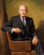
8. This achievement was a major stepping stone in what future movement?

President Dwight Eisenhower

Eisenhower and Post-World War II America
The former military general and architect of D-Day, Dwight Eisenhower, became president in 1953. Under his presidency, several international and domestic policies brought about technological advancements and social change. After World War II, soldiers returned home to America and settled back into the lives they had left behind. World War II veterans benefited from the G.I. Bill, a program that provided educational benefits, low-cost mortgages, unemployment compensation, and low-interest business loans. During this time, there was a huge growth in population, called the baby boom. From the mid-1940s to the mid-1960s, the birthrate quickly increased, reaching its high point in 1957, a year when over 4 million babies were born. The generation referred to as “baby boomers” is the largest generation in American history.
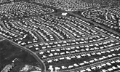
Another effect of the soldiers’ return was a housing shortage. The veterans’ new and growing families needed homes to live in. In response, housing developers such as William Levitt created methods of building houses faster, cheaper, and more efficiently. These methods led to the creation of the first suburbs—communities outside of a city and made up of mostly single-family houses for people whose family members worked in the city. The first master-planned community in America was William Levitt’s Levittown, located on New York’s Long Island.
Because the new suburbs were outside the limits of large cities, there was little public transportation available for the suburban residents. They needed cars, and increased car ownership meant more roads were needed, so Congress passed the Interstate Highway Act, authorizing the construction of a national network of highways to connect every major city in America. In all, 41,000 miles of new expressways, or freeways, were built. It was a record-size public works project.

1. What was the baby boom?

2. How did the G.I. Bill help World War II veterans?

3. Where was the first Levittown and what was it?

4. What did the Interstate Highway Act do?
Eisenhower and the Civil Rights Movement
1954––In the Brown v. Board of Education case, the U.S. Supreme Court declared that state laws establishing “separate but equal” public schools denied African American students the equal education promised in the Fourteenth Amendment. The Court’s decision reversed prior rulings dating back to the Plessy v. Ferguson case in 1896. Many people were unhappy with this decision, and some even refused to follow it. The governor of Arkansas ordered the National Guard to keep nine African American students from attending Little Rock’s Central High School; President Eisenhower sent federal troops to Little Rock to force the high school to integrate.

5. What was the decision in the Brown v. Board of Education Supreme Court case?

6. What did Eisenhower do as a result of the problem in Little Rock?

Eisenhower and the Cold War
In 1957, the Soviet Union launched the first artificial satellite—Sputnik I—a feat that caused many Americans to believe the United States had “fallen behind” the Soviet Union in terms of understanding science and the uses of technology. The success of the Soviet satellite launch led to increased U.S. government spending on education, especially in mathematics and science, and on national military defense programs. Additionally, Sputnik I increased Cold War tensions by heightening U.S. fears that the Soviet Union might use rockets to launch nuclear weapons against the United States and its allied nations.

7. What was Sputnik I, and what was the U.S. reaction?

President John F. Kennedy
The Election of 1960
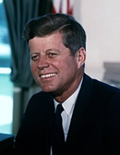
After announcing his bid as the Democratic candidate in 1960, John F. Kennedy faced off against the sitting vice president and Republican candidate, Richard Nixon, in the first ever televised presidential debate. Prior to 1960, candidates would travel the country and speak at several destinations and broadcast over the radio, this new media opened the world of American Politics to a wider range of individuals. The Kennedy-Nixon Debates (Great Debates) solidified the younger, more attractive and charismatic Democrat as the clear winner. Kennedy was physically fit, tan and well-groomed; while Nixon was not attractive, he sweat profusely and appeared sickly and frail due to a passing illness. Although the next day’s incoming polls among those that tuned in solely through radio broadcast, revealed that American viewers believed Nixon to be the more knowledgeable of the two presidential hopefuls, the power of positive imagery was clear. The Debates served not only as a determining factor in the Election of 1960, they also sparked an increased concern with the public image and overall appearance of politicians.

1. How did presidential candidates campaign prior to the Election of 1960?

2. Who did JFK face during the Great Debates?

3. Why was JFK’s victory secured during the debates (physical characteristics/ differences)?

4. How was the Election of 1960 different from previous elections?
Kennedy & the Cold War
After securing the presidency, Kennedy reminded the country that it was not just our duty to serve stateside but, it was equally important to fight the against the ongoing Cold War-political and geographic tension in Eastern Europe at the hands of the Soviet Union- and the spread of Communism. This threat was particularly evident for the U.S. through the countries of both Cuba and Vietnam. This idea is evident through the well-known phrase: “Ask not what your country can do for you; ask what you can do for your country.” In April 1961, Kennedy approved the plan to send over 1,000 Cuban-exiles into the Bay of Pigs in Cuba to inspire a coup that would overthrow the Communist leader, Fidel Castro. The mission failed and most of the exiles were murdered or captured.

5. What was the Cold War?

6. What was the Bay of Pigs? Was it a success?

Civil Rights & the Space Race
On the home front, Kennedy fought on the side of equality and Civil Rights. During his lifetime, Kennedy hoped to sign Civil Rights legislation to address the prejudice and inequalities faced by black, Hispanic, and other marginalized groups. His assassination would become a catapult for his predecessor, President Lyndon B. Johnson, to fulfill his dreams of signing a Civil Rights Bill into law. Kennedy also had his eyes set on the extraterrestrial, he believed that to win the space race with the Soviet Union (Russia), the U.S. had to plant their flag into the moon first. Another feat that was not accomplished in his lifetime but, by the end of the decade the U.S. was the clear winner with the lunar landing of Neil Armstrong and Buzz Aldrin and the planting of the American flag on the moon. Effectively winning the space race.

7. How could the United States win the space race?

Assassination
John F. Kennedy was assassinated on November 22, 1963 by Lee Harvey Oswald in Dallas, Texas. This assassination of the president had a profound effect on the nation, leaving many filled with feelings of emptiness, confusion and uncertainty about the course of the nation.

8. How and when did John F. Kennedy’s presidency end?

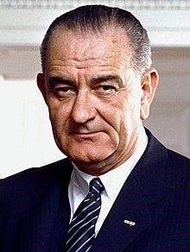
President Lyndon B. Johnson

Assuming JFK’s Presidency
Lyndon B. Johnson was the 36th president of the United States; he was sworn into office following the November 1963 assassination of President John F. Kennedy. Kennedy's death had a profound impact on the nation. The assassination gave the new President, Lyndon Johnson, political capital (The trust, and influence a politician has with the public and other political figures.) to force his domestic legislative package through Congress. The Civil Rights legislation that Kennedy supported but had not been able to get passed in the Congress was pushed through in 1964. Johnson depicted passage of the proposed Civil Rights law as being one of the best ways to honor the dead president's legacy.

1. What was the “political Capital” President Johnson used to push the Civil Rights Act of 1964?

The Great Society and Civil Rights
Upon taking office, Johnson launched an ambitious slate of progressive reforms aimed at creating a “Great Society” for all Americans. Many of the programs he championed—Medicare, Head Start, the Voting Rights Act and the Civil Rights Act—had a profound and lasting impact in health, education and civil rights. The Great Society was a series of federal government programs designed to remedy social problems in the United States during the 1960s. President Lyndon Johnson’s Great Society called for two specific reforms: to eliminate poverty and to end racial discrimination. In addition, President Johnson planned to introduce other reforms concerning transportation, medical care, education, and urban development.
The Civil Rights Act of 1964 outlawed major forms of discrimination against African-Americans and women. The law ended unequal application of voter registration requirements and the racial segregation of schools, places of work, and facilities that served the general public ("public accommodations").
· The Voting Rights Act of 1965 was passed the year after Congress moved on the issue of Civil Rights. This federal law made it illegal for African-American voters to be disenfranchised through unfair voter registration criteria. It ended the practice of using literacy tests as a qualification to vote
President Johnson ambitious legislative agenda created the Medicare and Medicaid programs. Medicare provides federal health insurance for the elderly and Medicaid, health care for underprivileged Americans. It also included measures aimed at preventing crime and reducing air and water pollution through the creation of the Environmental Protection Agency (EPA).
President Johnson also focused on educational reforms. He passed the Elementary and Secondary Education Act, which provided federal aid to education programs. This law created the Head Start Program that gave impoverished students a good foundation with which to enter schools. The Higher Education Act of 1965 aided colleges and universities because it allowed institutions to grant scholarships and loans to students.

2. What two legislative acts advanced the Civil Rights Movement?

3. What two programs provided healthcare to Americans?

4. What educational reforms were instituted through Johnson’s Great Society?

Like President Kennedy before him, Johnson was determined to prevent North Vietnamese communists from taking over the U.S.-supported government of South Vietnam. A believer in the “domino theory,” (A Cold War policy that suggested a communist government in one nation would quickly lead to communist takeovers in neighboring states, each falling like a perfectly aligned row of dominos.) Johnson worried that America’s security depended on containing the spread of communism around the world.
As part of this effort, Johnson steadily escalated U.S. military involvement in the Vietnam War. The number of American troops in Vietnam soared from 16,000 when he took office in 1963 to more than 500,000 in 1968, yet the conflict remained a draw.
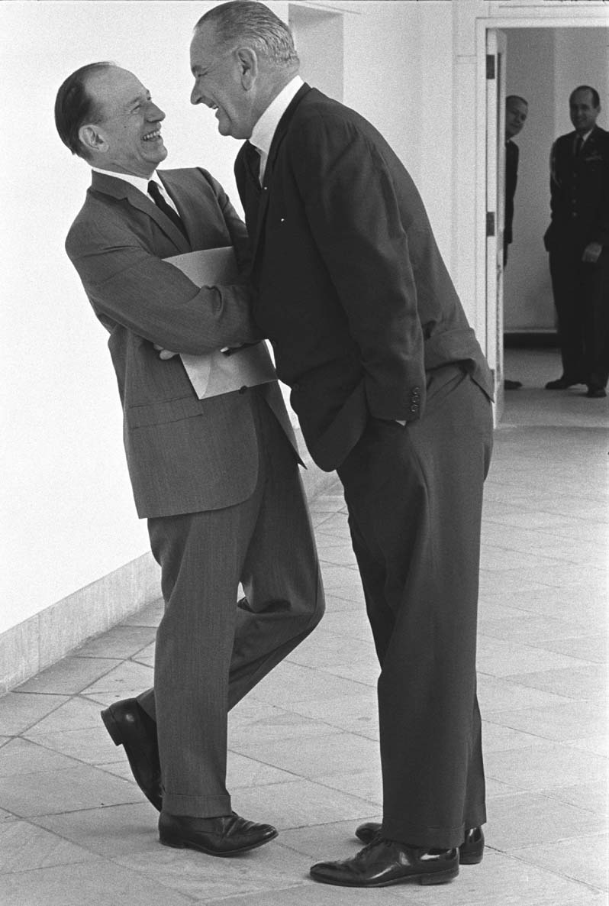
As the war dragged on and American and Vietnamese casualties mounted, anti-war protests rocked college campuses and cities across the U.S. Johnson’s popularity within the Democratic Party plummeted as well. When it appeared that he might face a stiff challenge for the 1968 Democratic presidential nomination, Johnson announced his decision not to run for re-election.

5. How did the domino theory increase U.S. involvement in Vietnam?

6. How was Johnson’s presidency impacted by the Anti-Vietnam War movement?

President Richard Nixon

Richard Nixon’s presidency was one of great successes and criminal scandals. Nixon’s visit to China in 1971 was one of the successes. He visited to seek scientific, cultural, and trade agreements and to take advantage of a 10-year standoff between China and the Soviet Union. Nixon hoped to have the Chinese on his side in case he had future negotiations with the Soviets. Later, Nixon was part of the Watergate scandal, which centered on his administration’s attempt to cover up a burglary of the offices of the Democratic Party in the Watergate apartment and office complex in Washington, D.C. The crime was committed by Nixon’s reelection campaign team, who sought political information. Nixon won reelection in 1972, but his efforts to cover up the crime soon unraveled and, facing impeachment, he resigned in 1974. The scandal left Americans dismayed by Nixon’s actions and cynical about politics in general. It also led to changes in campaign financing and to laws requiring high-level government officials to disclose their finances. Because Nixon and many of the people involved in Watergate were lawyers, the reputation of the legal profession suffered too.
Nixon was succeeded by his vice president, Gerald Ford, whose two-year presidency was damaged by his connection to Nixon. It was further damaged when he pardoned Nixon for any crimes he may have committed. One positive development during Ford’s presidency was that the Vietnam War ended during the Ford administration because it followed a path established by Nixon, but Ford’s domestic policies failed to stop growing inflation and unemployment, and America experienced its worst economic recession since the Great Depression.

- Why did President Nixon go to China?
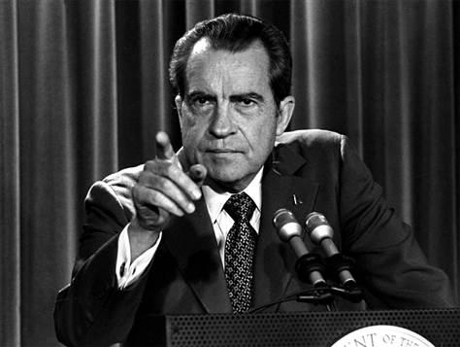

- What was the Watergate Scandal?

- Who committed the crime at the Watergate Hotel?

- Why did Nixon resign in 1974?

- What were the results of the scandal on the American public? (3 things)

- Who was Gerald Ford?

- Why was his presidency tainted?

- What did Ford do in regard to Nixon?

- What happened to the US as a result of Ford’s Presidency?

President Jimmy Carter

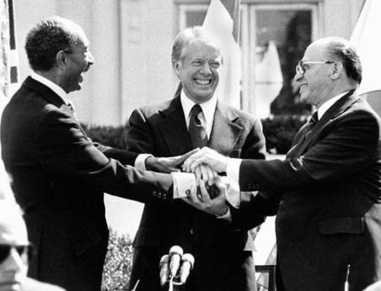
Jimmy Carter’s presidency was strongly influenced by international issues. He tried to bring peace to the Middle East and, in the Camp David Accords, negotiated a peace agreement between the Egyptian president and the Israeli prime minister at Camp David (a presidential retreat in Maryland) in 1978. This was the first time there had been a signed peace agreement between Middle Eastern nations. Although the agreement left many differences unresolved, it did solve urgent problems facing the two nations. In 1978, the Iranian Revolution replaced a shah (king) friendly to America with a Muslim religious leader unfriendly to America. When Carter let the shah enter the United States for medical treatment, angry Iranian revolutionaries invaded the U.S. embassy in Iran and took 52 Americans captive. The Iranian Hostage Crisis lasted 444 days, until the captives were released after the election of Ronald Reagan as president, and it nurtured anti-Americanism among Muslims around the world.

- What was Jimmy Carter’s Presidency strongly influenced by?

- What happened at the Camp David Accords?

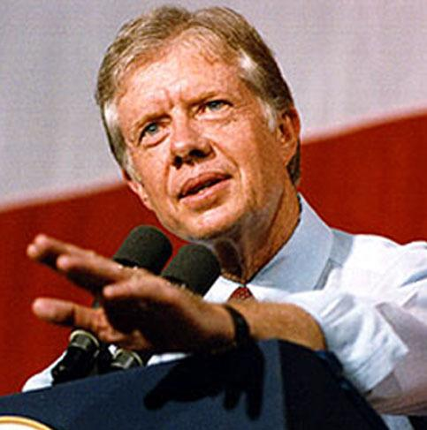

- What was the Iranian Revolution?

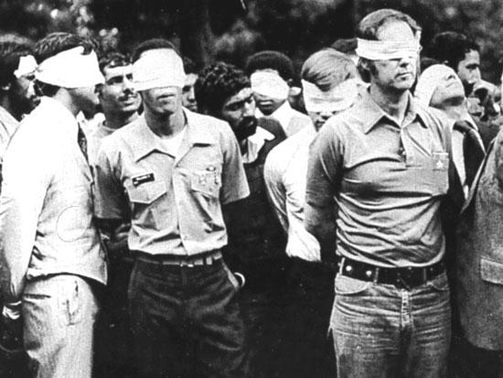

- What happened in the Iranian Hostage crisis?

President Ronald Reagan
Reaganomics
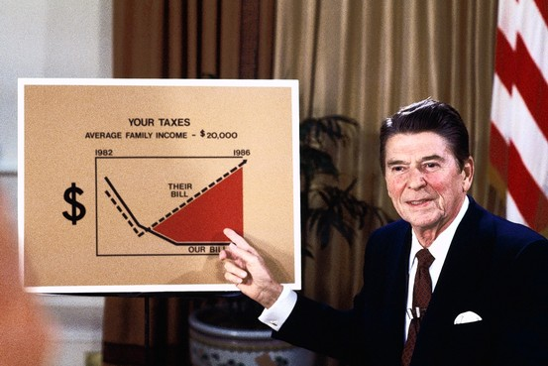
President Reagan campaigned on a promise that pledged to restore the United States' economy and prestige at home and abroad. To address the 1970s stagnant economy, President Reagan instituted what became known as Reaganomics. One basic principle of his domestic policy was the belief in supply-side economics, often referred to as Reaganomics. President Reagan held that if Americans had more money to spend, then the economy would improve. There were four key components to Reaganomics.
1. Reduce government spending
2. Reduce income tax and capital gains tax
3. Reduce government regulation
4. Control the money supply to reduce inflation

In general, the United States experienced a sustained period of economic growth during the period. However, amidst high Cold War defense spending, federal deficits also increased dramatically, which led to economic problems in the 1990s.

1. When President Reagan took office in 1980, what was the condition of the economy like throughout the past decade (1970s)?

2. What did Reagan hope to accomplish by imposing tax cuts and other measures of supply-side economics (Reaganomics)?

Reagan and the Cold War
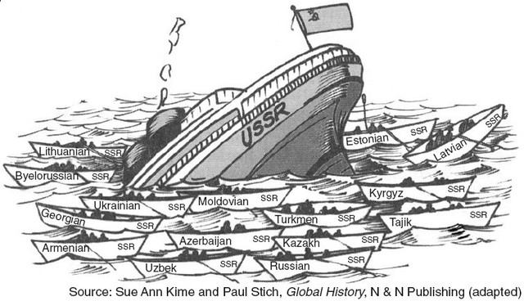
President Reagan began applying pressure to the Soviet Union by increasing defense spending, even initiating a program to weaponize space technology. The Soviets could not afford to keep up with US defending as the Soviet economy fell into decline after years of failure in agricultural and industrial production. The Soviet President, Mikhail Gorbachev, decided to begin a policy of Perestroika (economic rebuilding) and Glasnost (political reform). President Gorbachev set up policies allowing free speech, free press, and other reforms. The changes put the Soviet Union on a path to democratic government. President Reagan played on these changes and began open dialogue with Gorbachev. The more cooperative relationship between the Cold War rivals resulted in a nuclear arms agreement between the United States and the Soviet Union. Gorbachev's reforms led to a collapse of the Soviet Union through a reduction in the Kremlin's control over the various states that comprised the Soviet Union. The Eastern European nations, which had been satellite states of the Soviet Union since the close of World War II, also rebelled against their oppressor and established their own democratic states.
By 1989, the Cold War was over, and the Soviet Union was disbanded. The effort of President Reagan to foster the relationship with Gorbachev helped to end the Cold War and was a highlight of his presidency. After Ronald Reagan served two terms as President, his Vice President George H. W. Bush was elected in 1988. He served one term, which included a costly economic downturn and the successful use of military resources in the 1991 Persian Gulf War against Saddam Hussein in Iraq. President George H. W. Bush lost his reelection bid to the Democratic Candidate, Bill Clinton, in 1992.

3. How did Reagan apply pressure to the Soviet Union?

4. Why did the Cold War come to an end?

5. Against which nation did George H. W. Bush successfully engage military involvement in the Persian Gulf War of 1991?

President Bill Clinton
Economic Policy
The later economic challenges that George H.W. Bush experienced during his term in office were taken on by President Bill Clinton in his 1990s effort to end the budget deficit through tax cuts and reduced federal spending.

1. How did Clinton’s economic policies compare to Reagan’s?

NAFTA
Bill Clinton’s presidency included ratification of the North American Free Trade Agreement. NAFTA brought Mexico into a free-trade (tariff-free) zone already existing between the United States and Canada. Opponents believed NAFTA would send U.S. jobs to Mexico and harm the environment, while supporters believed it would open up the growing Mexican market to U.S. companies; these pros and cons are still argued today.
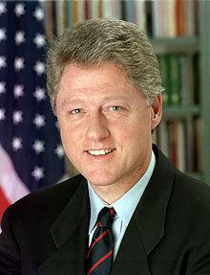
2. What did Bill Clinton’s presidency include that is still important?
3. What does NAFTA stand for?

4. What is NAFTA?

Impeachment
Clinton also became the second president in U.S. history to suffer impeachment. The House of Representatives charged him with perjury and obstruction of justice. The charges were based on accusations of improper use of money from a real estate deal and allegations he had lied under oath about an improper relationship with a White House intern. Clinton denied the charges and the Senate acquitted him, allowing Clinton to remain in office and finish his second term.

5. Why was Clinton impeached?

6. What was the outcome of Clinton’s impeachment trial?

President George W. Bush

2000 Presidential Election
The presidential election of 2000 saw Clinton’s vice president, Al Gore, facing the
Republican governor of Texas, George W. Bush, as well as consumer advocate Ralph Nader, who ran as a third-party candidate. Polls showed the race would be close, and it turned out to be one of the closest elections in American history. Gore won the national popular vote by over 500,000 of the 105 million votes cast, but when American voters cast ballots for president, the national popular vote has no legal significance. Rather,
Americans are voting for members of the Electoral College representing each candidate.
Each state is assigned “electors” in equal number to its total number of U.S. representatives and senators. (For example, Georgia had thirteen electors in 2000: eleven representatives and two senators.) In the 2000 election, Bush won by receiving 271 votes in the Electoral College to Gore’s 266.
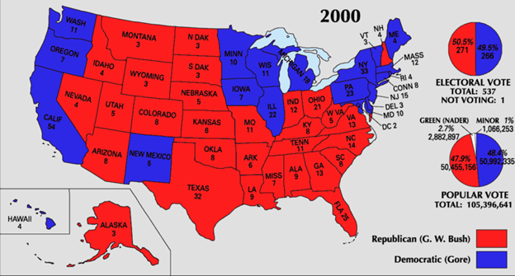

1. Which two candidates were involved in the 2000 Presidential Election?

2. Even though Gore won the popular vote in the election, why did Bush win?

Bush Administration
George W. Bush’s presidency will always be remembered for al-Qaeda’s attacks on September 11,
2001 (9/11). In response, and with overwhelming support of both Congress and the American people, Bush signed a law the next month to allow the U.S. government to hold foreign citizens suspected of being terrorists for up to seven days without charging them with a crime. This law also increased the ability of American law-enforcement agencies to search private communications and personal records. Then he created the Department of Homeland Security and charged it with protecting the United States from terrorist attacks and with responding to natural disasters.

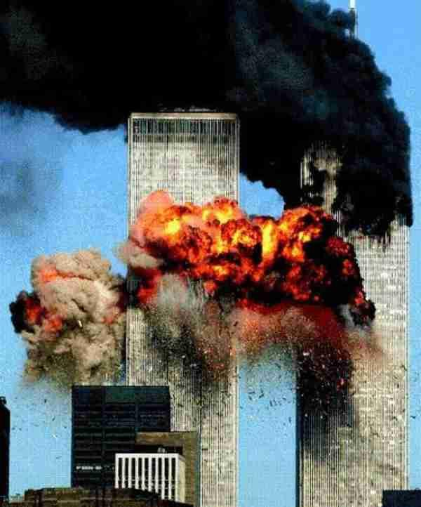
In October 2001, another of Bush’s responses to the 9/11 terrorist attacks was his authorizing Operation Enduring Freedom, the invasion of Afghanistan by the U.S. military and allied forces. That country’s Taliban government was harboring the al-Qaeda leadership. The allied forces quickly defeated the Taliban government and destroyed the al-Qaeda network in Afghanistan; however, al-Qaeda leader Osama bin Laden escaped. The invasion of Afghanistan was part of Bush’s larger war on terrorism, for which he built an international coalition to fight the al-Qaeda network and other terrorist groups. During the War on Terror, President George W. Bush increased spending in the wake of the September 11th attacks. In March 2003, American and British troops invaded Iraq in Operation Iraqi Freedom. Iraq’s president, Saddam Hussein, went into hiding while U.S. forces searched for the weapons of mass destruction (WMD) that Bush feared Hussein had and could supply to terrorists for use against the United States. No WMD were found before Hussein was captured. He was convicted of crimes against humanity and executed in 2006.

3. Why is September 11, 2001 important?

4. What laws did Bush sign in as a result of the 9/11 attacks?

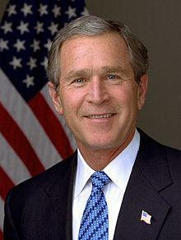
5. How did the War on Terror impact President Bush’s economic policies?

6. What was Operation Enduring Freedom?

7. What was Bush’s “War on Terrorism;” what did it include?

8. What was Operation Iraqi Freedom?

President Barack Obama
Obama Administration
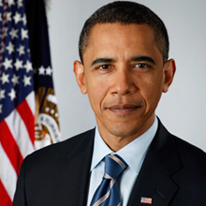
The election of 2008 brought about an important historical event in American history. Barack Obama became the 44th president of the United States. He was the first African American elected president in the United States. The 2008 election witnessed a historic number of youth and minority voters participating in the presidential election. President Obama worked tirelessly to help people of all social and economic backgrounds during his presidency. He entered office with the economic recession of the early 2000s. His economic policy included a stimulus package to increase jobs and economic growth. Significant events occurred during his presidency, including the passage of his controversial healthcare reform plan, Osama bin Laden was eliminated by a Navy Seal team, and a growing conservative movement that opposed his efforts.
1. Why was the election of 2008 historic in nature?
2. What significant events occurred during his presidency?

